**OBJECT ORIENTED ANALYSIS AND DESIGN**

**ANALYTICAL QUESTIONS DAY 1**

1. **AIM:** To develop UML diagrams for Passport Management System.
2. **Deployment Diagram:**

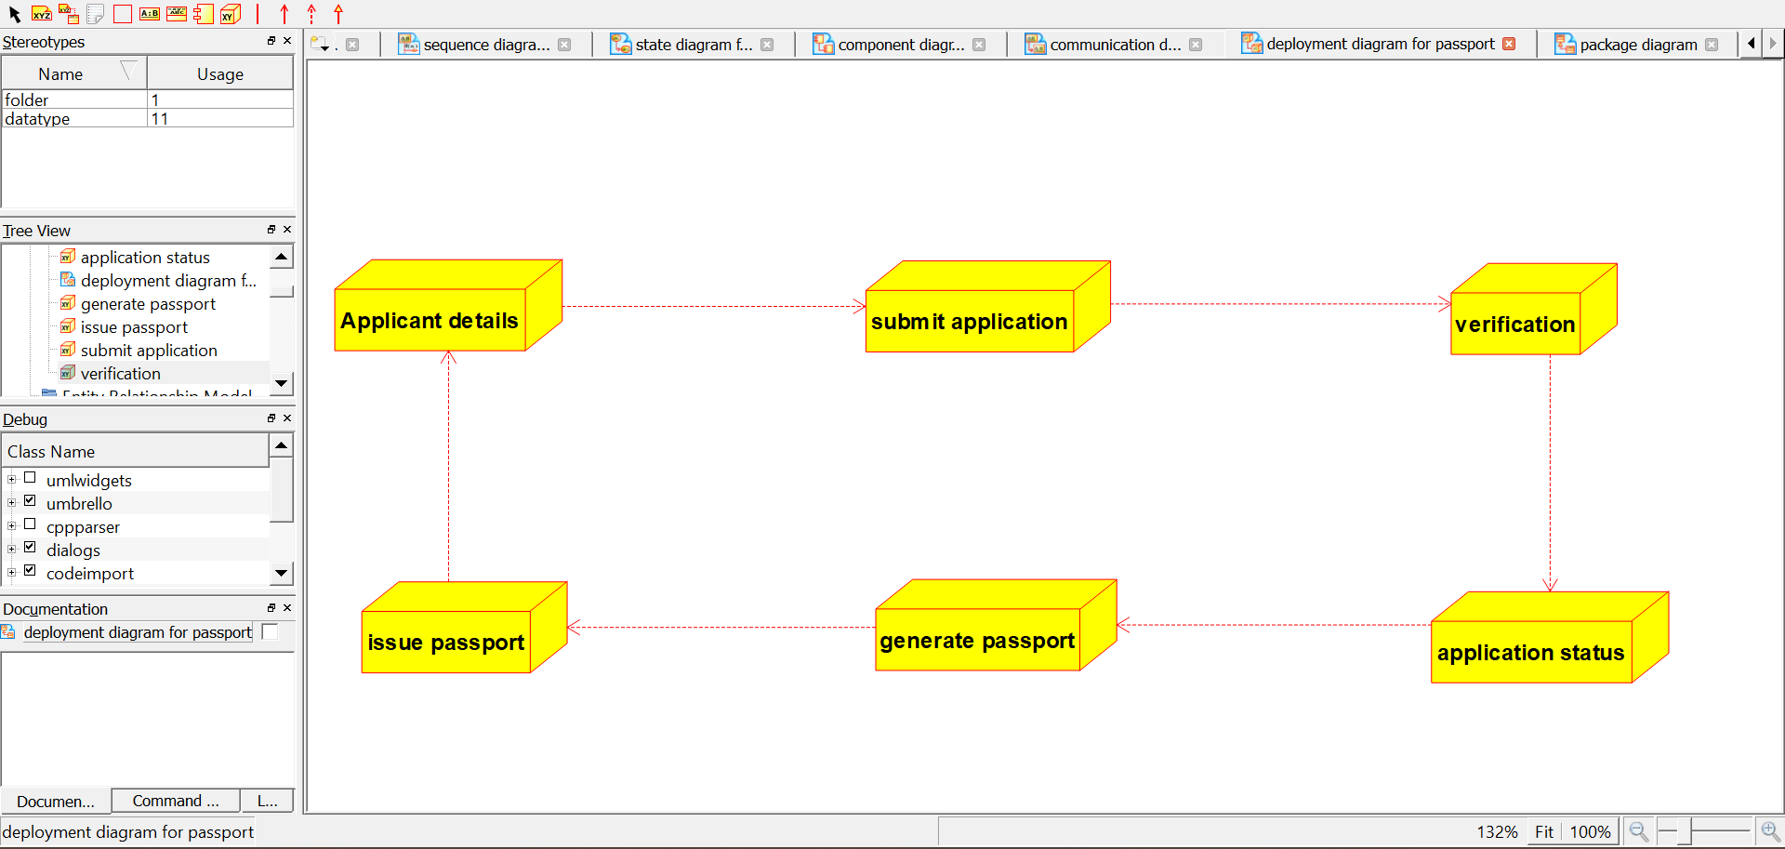

1. **Package Diagram:**

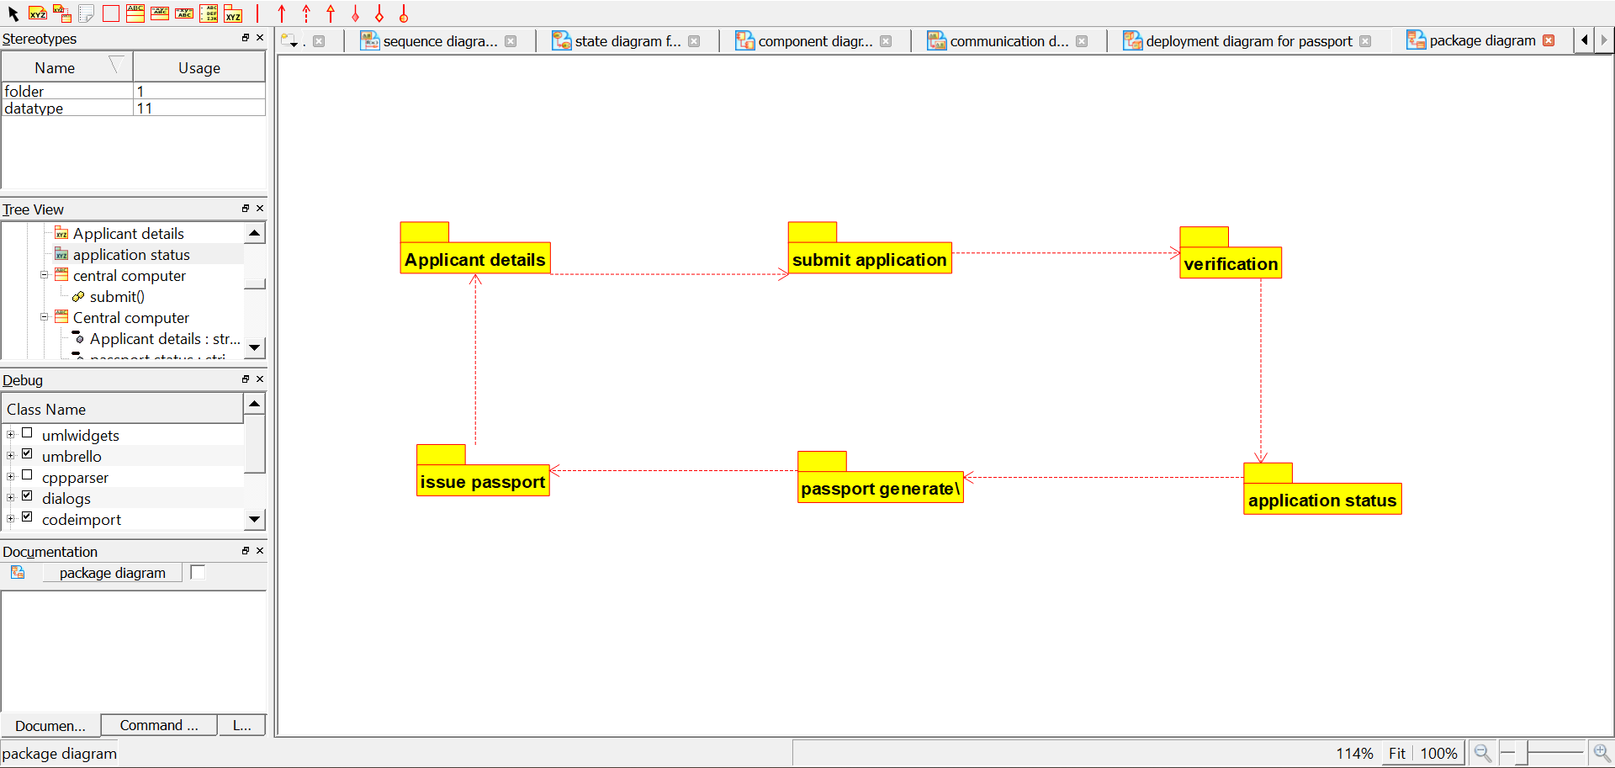

1. **Component Diagram:**

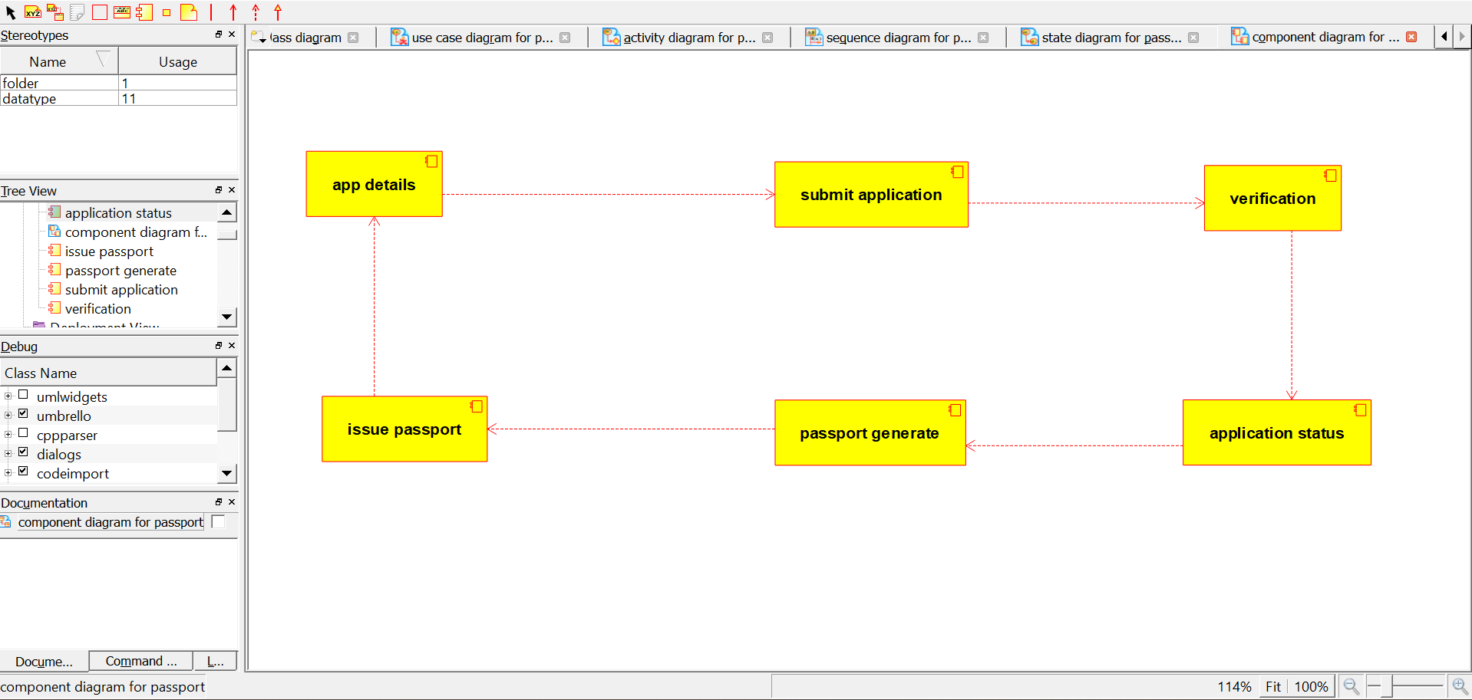

1. **Collaboration diagram:**

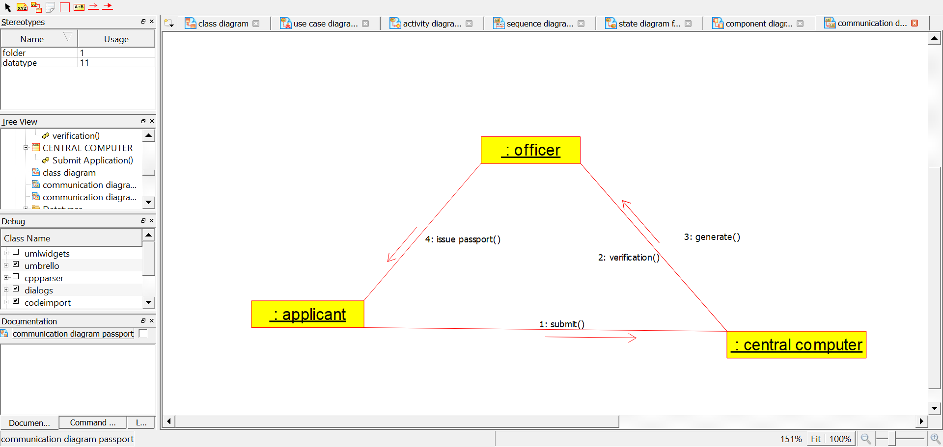

1. **Sequence diagram:**

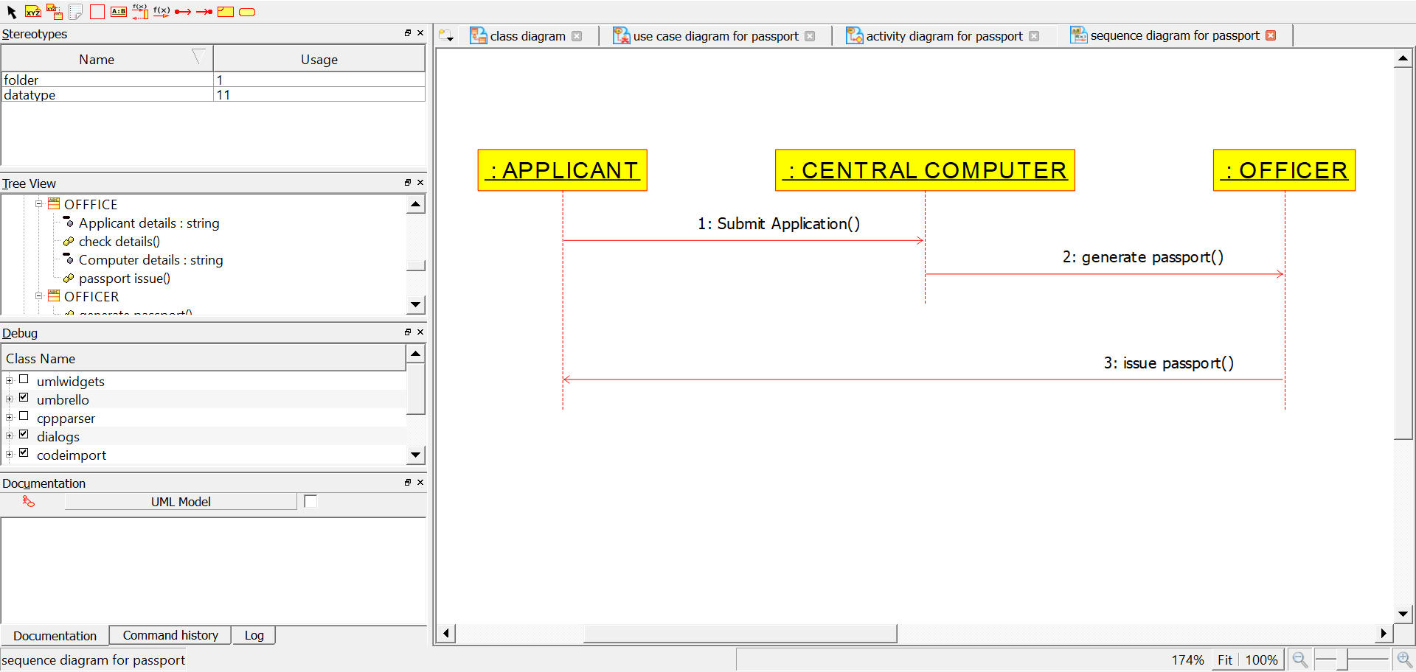

1. **State chart diagram:**

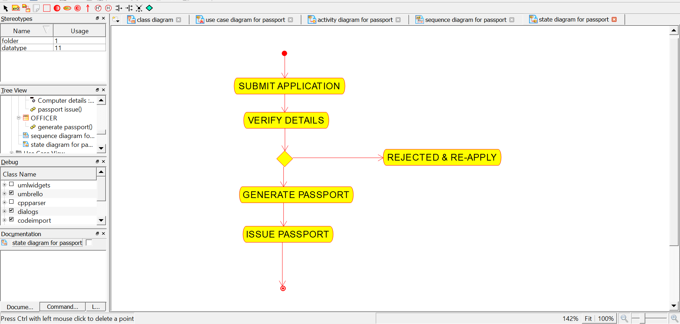

1. **Activity diagram:** 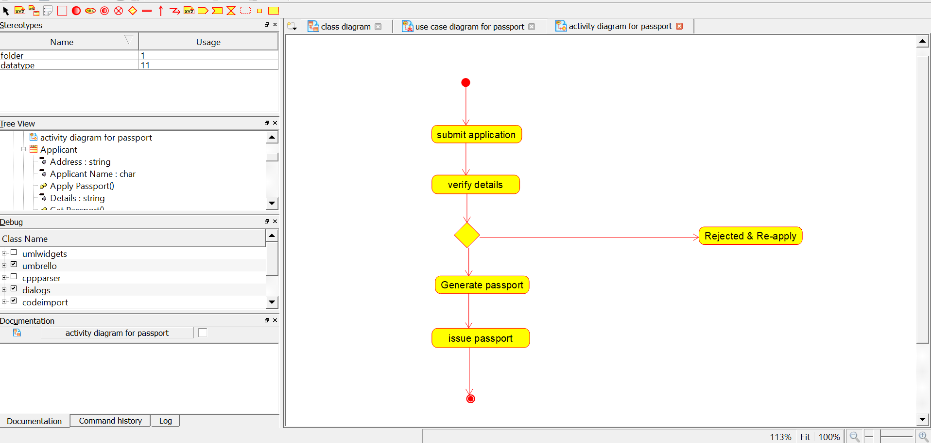
2. **Use-Case diagram:**

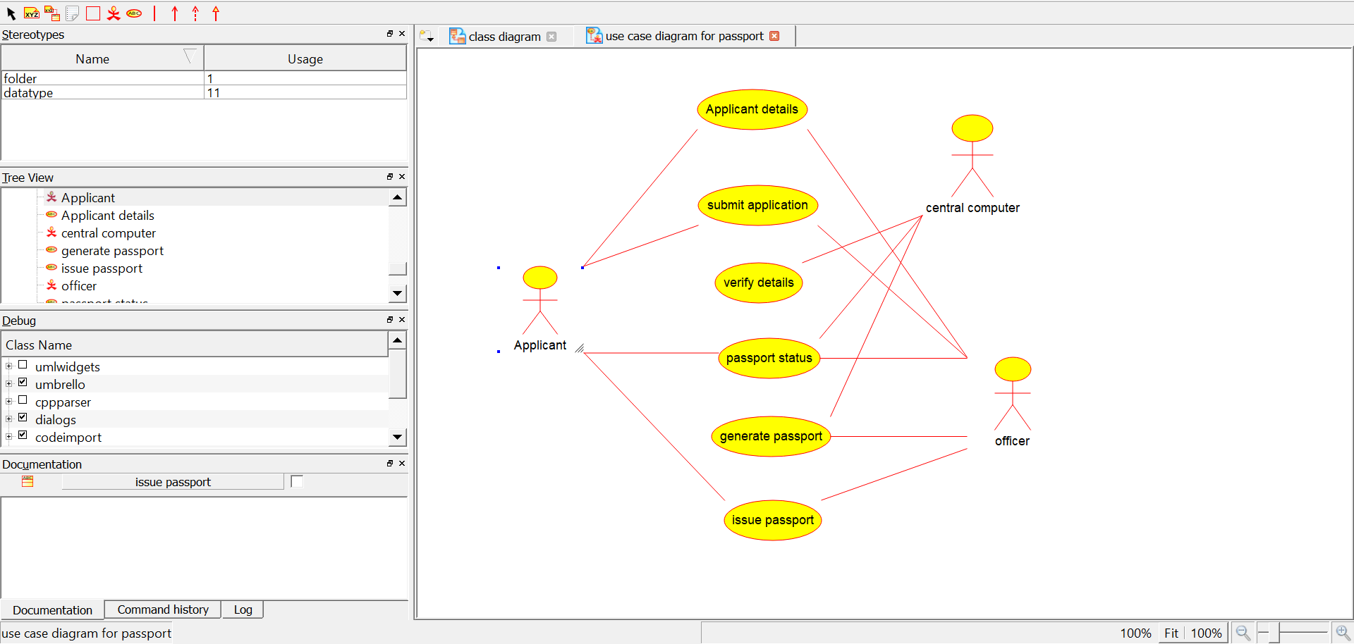

1. **Class diagram:**

